**Chapter 4: MINIMIZATION TECHNIQUES**

**Topic – 1: Minimization Of DFA**

**Aim**

* We get **finite state machine** (**FSM**) with redundant states, after minimization.

**Steps Involved**

* **Step 1:** **Remove** all the **unreachable states**.
* **Step 2:** Draw the **transition table**.
* **Step 3:** **Split the table** into two tables, **T1** containing **final states** & **T2** containing **rest** of the states.
* **Step 4:** Find rows from **T1** which are transitioning to **same state** or **set of states**, for receiving **all** the input symbols.
* **Step 5:** **Remove** one of those rows.
* **Step 6:** Keep doing it for **each common rows** found.
* **Step 7:** Now combine **T1** and **T2**.
* **Step 8:** Draw the **state diagram** as per the final obtained table.

**Example**

**Initial DFA:**

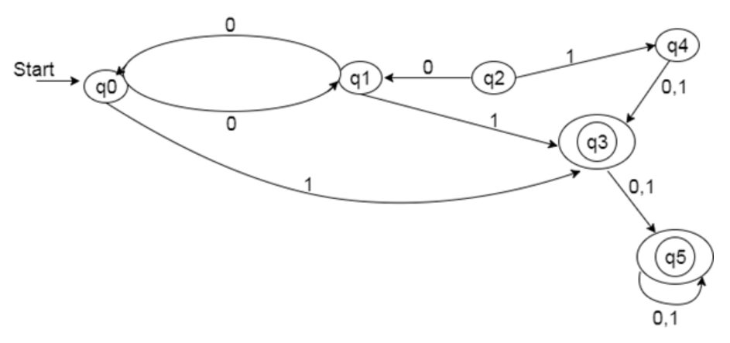

**Initial table:**

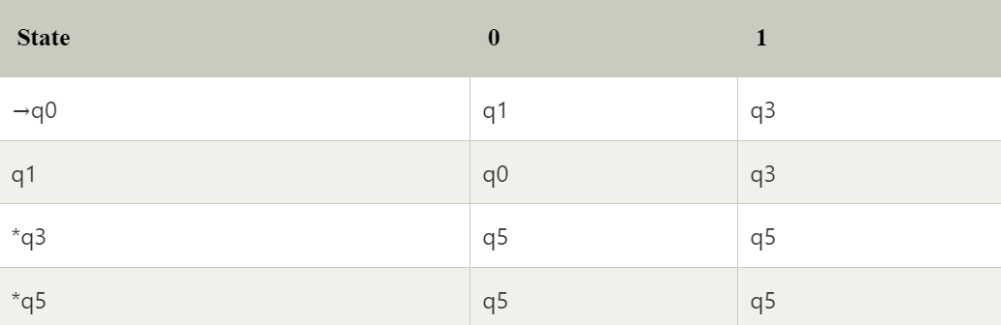

**T1:**



**T2:**



**Final table:**

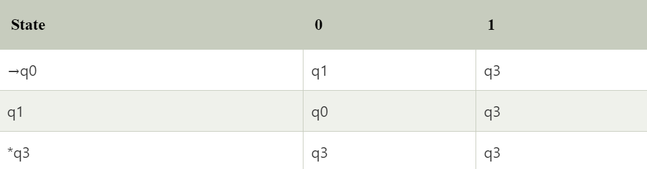

**Final DFA:**

